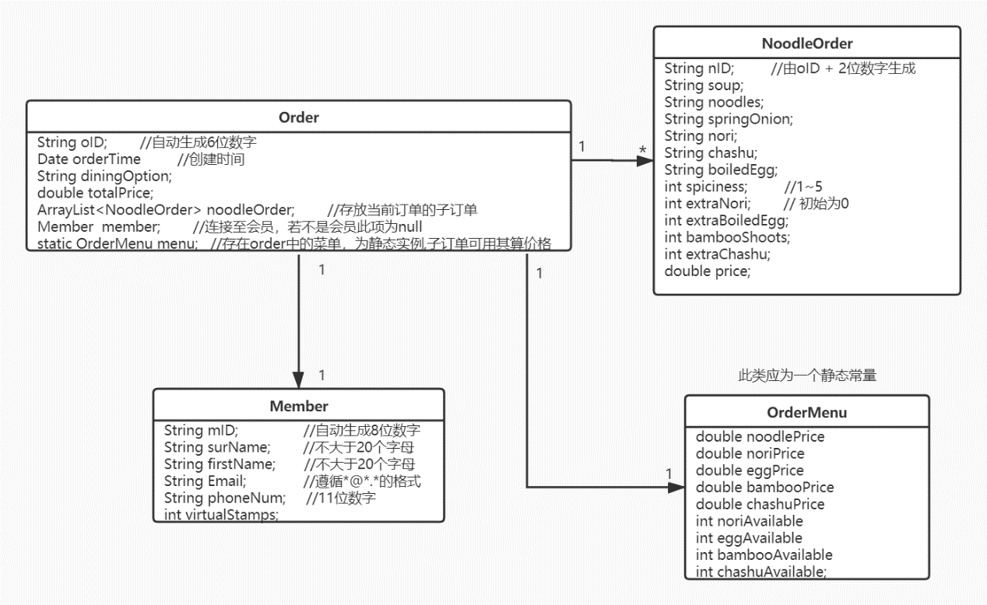

**1.Order**

OID 星期（1~7） + 递增生成 configure.csv 0

public Order (time);

setter and getter (orderTime diningOption totalPrice);

boolean addNoodleOrder(NoodleOrder );

Boolean addMember(Member);

Boolean outputOrder() 文件名oID，第一行为前四个属性，第二到最后是NoodleOrder里所有的信息

String toString()

2.Noodle Order

NID = OID + 从开始00递增得数

Setter and getter

Boolean changeMenu(int nori int egg int bamboo int chashu);

3.Member

OID递增生成 configure.csv

Setter and getter 格式检查

outputMember member.csv 5列

4.Ordermenu

Ordermenu 需要从menu.csv读取

Setter and getter

outputMenu menu.csv 九个数

boundary controller entity

Reader

New CSVreader CSVweriter

Writer